Final Iteration Dec 17 9am (Saturday)

Final Exam is PDF for online, 1 ½ hrs

* 1st question will be a Use Case
* 2nd Questioned Object Oriented Analysis
  + UML diagram, with attributes and associations/arrows
  + One-to-many is only required
* 3rd Question Entity Boundary Controller
  + UML Diagram with Entity Boundary Controllers Classes
  + 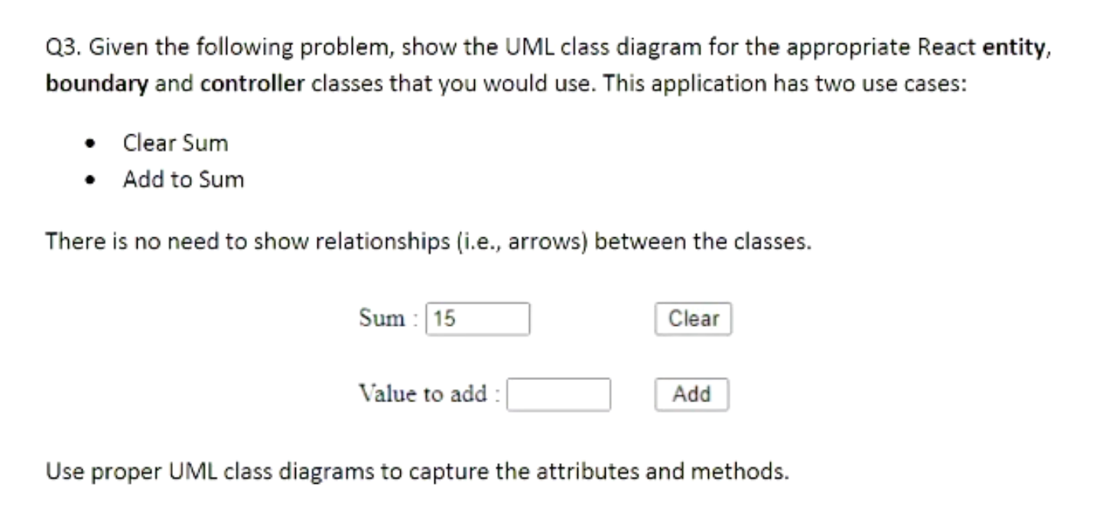
  + Clear and Add are 2 controllers
  + Must include Methods, setters and getters are assumed
  + 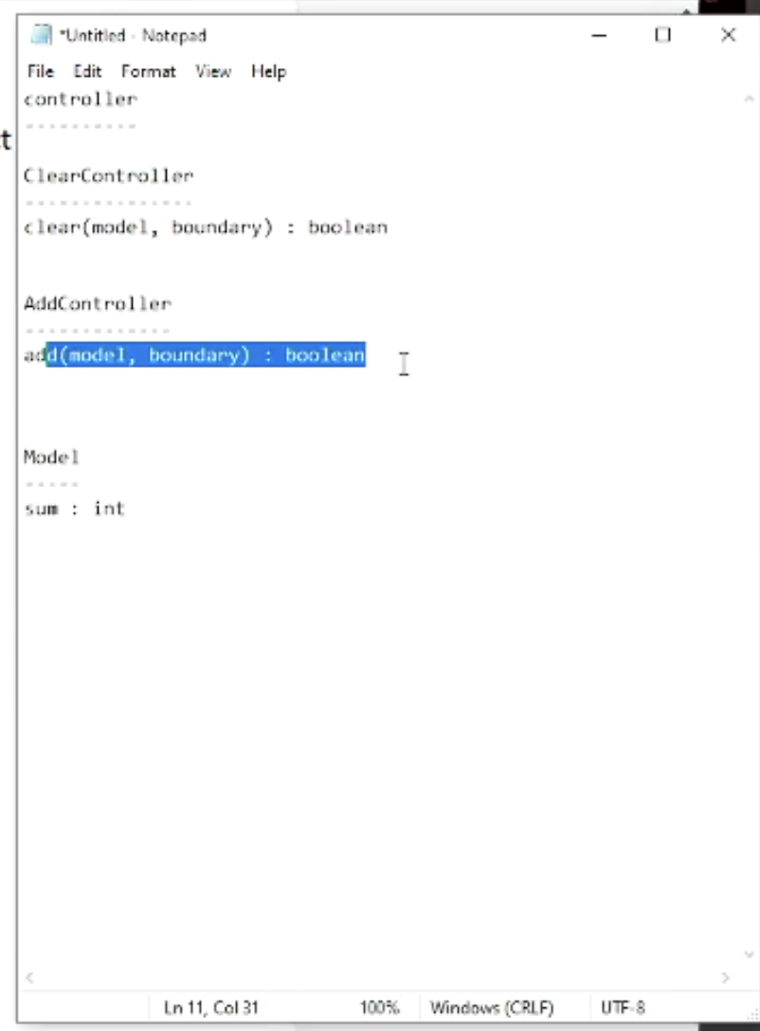
    - Value to add is more transient so does not belong in the model

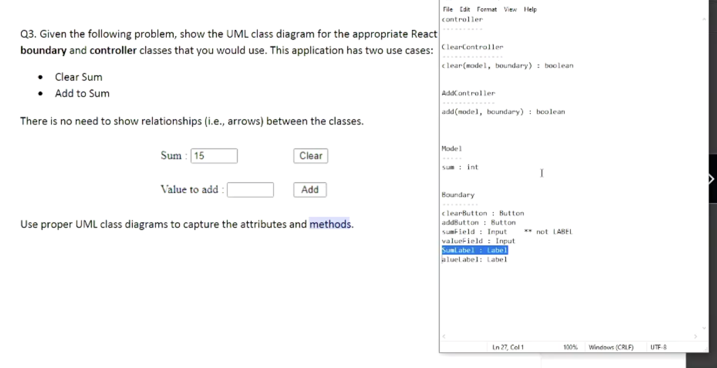Sumlabel is the (Sum: ) and Value Label us (Value to add: )

* 4th Question Get and Post JSON requests (JSON Notation!!!) API question.
  + 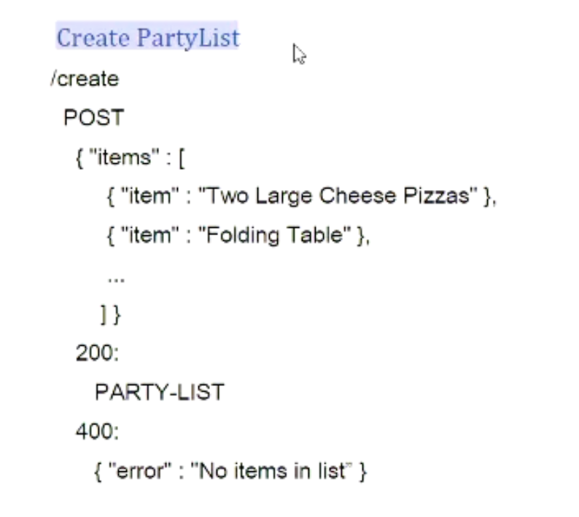
  + 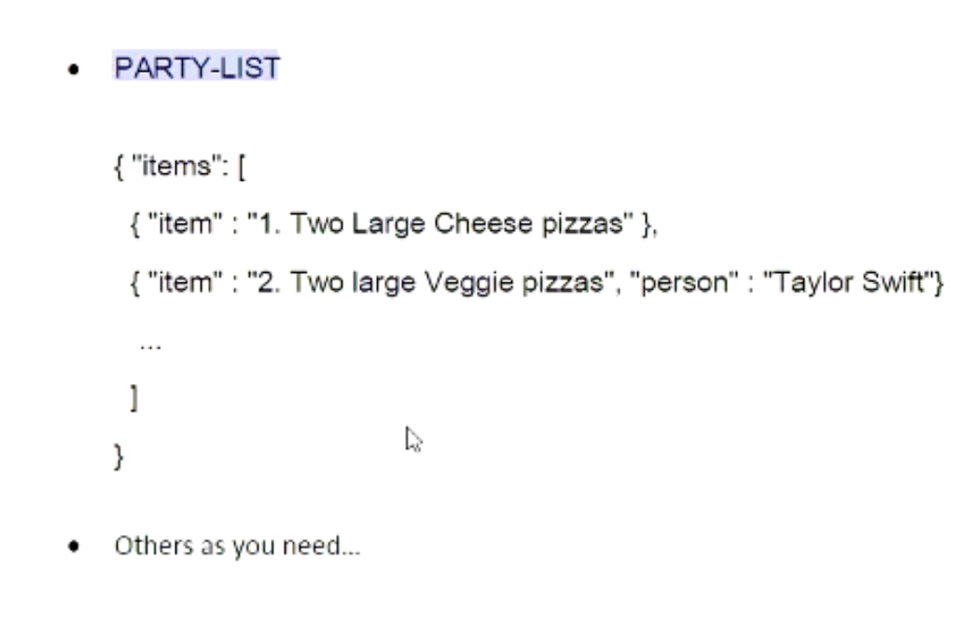
  + Always have one 400 error!!! Even for GET requests.
  + Can have empty 200.
* 5th Question is on AWS. High-Level Concepts
  + What is a lambda
    - Serverless
  + What does API-Gateway let you do
  + Codecommit
  + Cloud 9
* So, are there any questions around design patterns and interface?
  + NO!!!!!!!!!